A64_0_65_REF_DDR3_16X2_V1_0_20150421
Layout Note

1 | Stackup - Impadence -Trace Width
 | 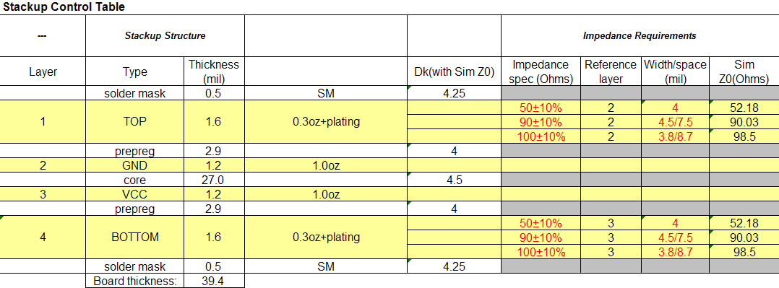
2 | 走线宽度
 | 单端：外层走线线宽4mil，内层4mil。
 | 差分：外层走线线宽/线距为3.8/8.7mil。
 | 电源和地Fanout线宽：≥10mil。
3 | 间距
 | 单端：外层线与线的间距（Air Gap）≥8mil,内层≥8mil。
 | 差分线：到其他网络走线间距≥15mil。
 | 电源与地：到其他网络走线的间距≥15mil。
 | VREF：到其他网络走线的间距≥12mil。
 | BGA区域里：线与线4mil；线与SMD PIN 4mil；线与过孔4mil。
4 | 拓扑
 | DQ：单点对单点
 | DQSP、DQSN：单点对单点
 | SAx、SBAx、SCAS、SRAS、SWE、SCSx、SODTx、SCKEx、SRST：远端簇型
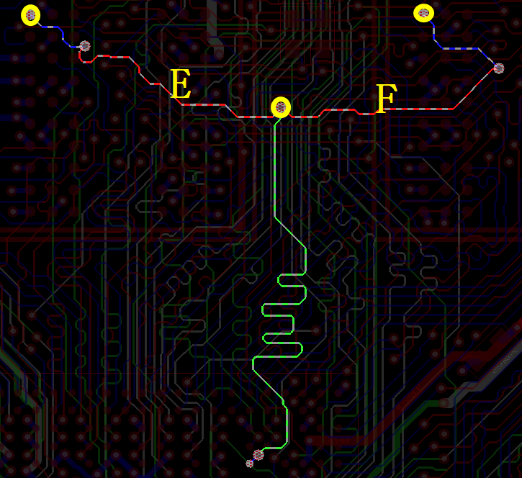
对于两片颗粒：
E < 600mil，
F < 600mil，
E - F < +/- 50mil。
 | SCKP、SCKN：远端簇型
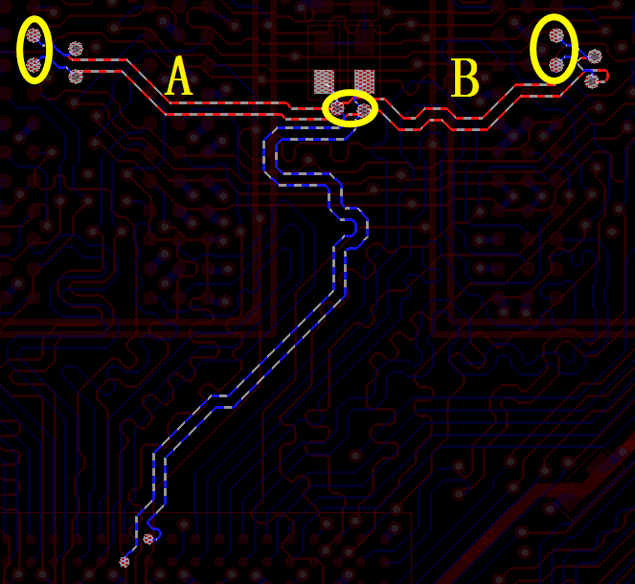
对于两片颗粒：
A < 600mil，
B < 600mil，
A - B < +/- 50mil。
5 | 等长
SDQ0-7：相对于SDQS0P、SDQS0N做等长，误差范围为+/- 50mil。过孔数一致。
SDQ8-15：相对于SDQS1P、SDQS1N做等长，误差范围为+/- 50mil。过孔数一致。
SDQ16-23：相对于SDQS2P、SDQS2N做等长，误差范围为+/- 50mil。过孔数一致。
SDQ24-31：相对于SDQS3P、SDQS3N做等长，误差范围为+/- 50mil。过孔数一致。
SDQSxP、SDQSxN:
相对于SCKP/SCKN信号做等长，误差范围为+/- 800mil。
SAx、SBAx、SCAS、SRAS、SWE、SCSx、SODTx、SCKEx：
相对于SCKP/SCKN信号做等长，误差范围为+/- 500mil。
SDQSxP与SDQSxN等长，等长误差范围为+/- 10mil。
CK与CKB等长，等长误差范围为+/- 10mil。
 | 信号线做等长时要考虑过孔长度的影响
6 | 电源、地平面
平面比较完整，调整好过孔的位置、间距，减少对电源、地平面的破坏。平面断开处用走线连接
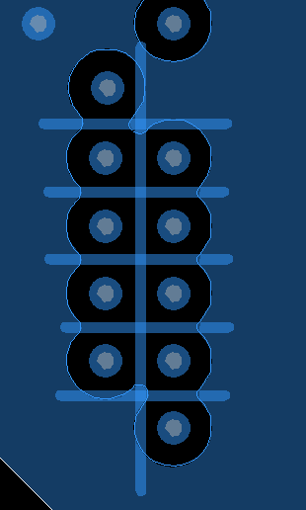

电源、地平面同时也是信号的参考层要求，不能有信号线的参考层被割断的现象
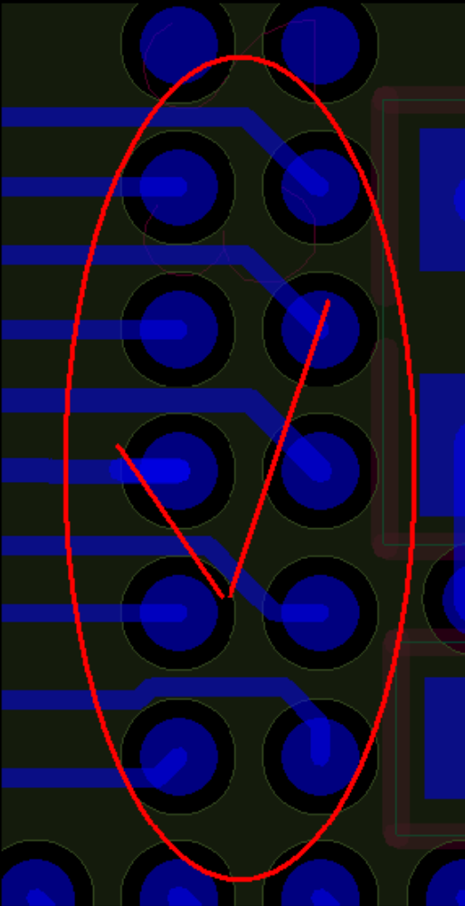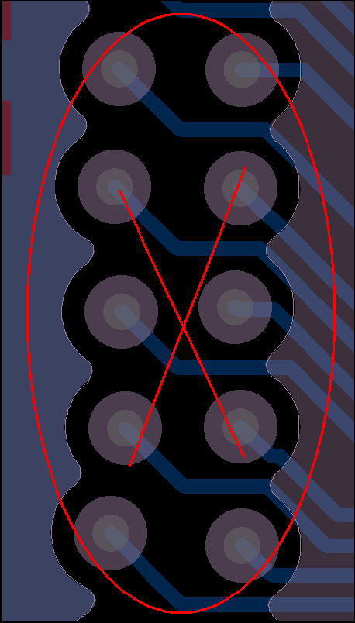
7 | 滤波电容：
 | 对于单面布局：尽量靠近电源PIN放置，每个电容至少各一个电源过孔和地过孔。

Declaration
This document is the original work and copyrighted property of Allwinner Technology (“Allwinner”). Reproduction in whole or in part must obtain the written approval of Allwinner and give clear acknowledgement to the copyright owner.

The information furnished by Allwinner is believed to be accurate and reliable. Allwinner reserves the right to make changes in circuit design and/or specifications at any time without notice. Allwinner does not assume any responsibility and liability for its use. Nor for any infringements of patents or other rights of the third parties which may result from its use. No license is granted by implication or otherwise under any patent or patent rights of Allwinner. This datasheet neither states nor implies warranty of any kind, including fitness for any particular application.

